

*DRAFT*

**CONSULTATION DOCUMENT**

**Second phase consultation of Social Partners under Article 154 TFEU on a possible action addressing the challenges related to fair minimum wages**

1. **INTRODUCTION**

The EU has been particularly hit by the Covid-19 outbreak, with negative effects on Member States’ economies, businesses, and the income of workers and their families. As the EU prepares for the recovery from this unprecedented crisis, our objectives of promoting socially fair transitions towards climate-neutral and digital economies are more important than ever.

**Ensuring that all workers in the EU earn a decent living is essential for the recovery as well as for building fair and resilient economies, and minimum wages have an important role to play**:when set at adequate levels, they help vulnerable workers to build up a financial buffer during good times and limit the fall in income during bad times, thus helping them to face economic downturns. They help sustain domestic demand, strengthen incentives to work, reduce wage inequalities and in-work poverty and contribute to closing the gender pay gap. At the same time, sound minimum wage setting mechanisms help to ensure that minimum wage updates take into account economic conditions and thus safeguard both jobs and the competitiveness of firms.

**Yet in recent decades, low wages**[1] **have not kept up with other wages in many Member States,** thus affecting income inequality, in-work poverty, and the capacity of low-wage earners to cope with economic distress. About one in six workers in the EU earns a low wage and this share has been on a rising trend. In-work poverty has also increased. Many low-wage workers were hit hard by the crisis, in particular the young, the low-skilled and those in precarious forms of employment. Fostering upward social convergence benefits both workers and businesses in the EU. It contributes to a better level playing field in the Single Market, where competition is based on innovation and productivity coupled with adequate social standards.

Collective bargaining is key to achieve adequate pay and quality jobs. Over the last decades, collective bargaining has contributed to reducing wage inequality and improving the situation of low-wage workers in Europe, even though its role has weakened in many countries in recent years. Statutory minimum wages also play an important role to help protect workers with low wages and low bargaining power even if they may not always achieve this objective in a satisfactory manner.

All these considerations translate into an overarching goal: “*to ensure that every worker in our Union has a fair minimum wage*” allowing “*for a decent living wherever they work*”, as stated by President von der Leyen.[2] In line with the Treaty provisions, the Commission launched on 14 January 2020 the first-stage consultation of the social partners to request their views on the need and possible direction of EU action to address the challenges related to fair minimum wages. This first stage consultation ended on 25 February 2020. After considering the views expressed by the social partners in the first-stage consultation, the Commission has concluded that there is a need for EU action to address these issues. Therefore, **the Commission is now launching the second-stage consultation of the social partners, in accordance with Article 154(3) of the Treaty on the Functioning of the European Union (TFEU). The social partners are being consulted on the possible content and instrument of the envisaged proposal.** The consultation period will be extended to take into account the current circumstances related to the Covid-19 crisis and grant social partners sufficient time to submit their replies.

As underlined in the first-stage consultation of the social partners, in line with Articles 151 and 153(5) TFEU, which forbids the EU to intervene directly on the level of pay so as not to interfere with the competence of Member States and autonomy of social partners in this field, as well as the constant case-law of the Court of Justice of the European Union (CJEU),[3] any possible EU action in the field of minimum wages would neither seek to harmonise the level of minimum wages across the EU nor to establish a uniform mechanism for setting minimum wages. It would also respect national traditions, social partners’ autonomy and the freedom of collective bargaining. It would not establish the level of pay which falls within the contractual freedom of the social partners at the national level and within the relevant competence of Member States. In particular, EU action would not seek the introduction of a statutory minimum wage in all Member States. Minimum wages would continue to be set through either collective agreements or legislative provisions, according to the traditions and specificities of each country and in full respect of national competencies and social partners’ contractual freedom.

This document brings together the main results of the first-stage consultation, provides an analysis of the main challenges, discusses the need and added value of EU action, and sets out possible options that could be considered for an initiative at EU level. It is accompanied by an analytical document,[4] which underpins the arguments laid out in this consultation document, and explores the potential impact of the different policy options set in the present document. The next step to this second stage consultation is either negotiations between social partners with a view to concluding an agreement under Article 155 TFEU or the presentation of a proposal by the European Commission.

1. **THE FIRST-STAGE CONSULTATION OF SOCIAL PARTNERS**

The first stage consultation of social partners was open from 14 January to 25 February 2020. The Commission received 23 replies from European social partners representing trade unions and employers’ organisations at EU level.

Five trade unions replied to the first stage consultation: the European Trade Union Federation (ETUC), Eurocadres, the CEC European managers, the European Arts and Entertainment Alliance (EAEA) and the European Confederation of Independent Trade Unions (CESI). ETUC’s reply also represents the views of ten European sectoral trade union organisations.

On the employers’ side, 18 organisations replied to the consultation, namely BusinessEurope, the European Centre of Employers and Enterprises providing Public Services (CEEP), SMEunited, the Council of European Employers of the Metal, Engineering and Technology-Based Industries (CEEMET), the European Confederation of the Woodworking Industries (CEI-Bois), the Council of European Municipalities and Regions (CEMR), the Confederation of European Security Services (CoESS), the European Chemical Employers Group (ECEG), the European Cleaning and Facility Services Industry (EFCI), the European Furniture Industries Confederation (EFIC), the Retail, Wholesale and International Trade Representation to the EU (EuroCommerce), the European Construction Industry Federation (FIEC), the Hotels, Restaurants and Cafés in Europe (HOTREC), the European Federation for print and digital communication (Intergraf), the International Road Transport Union (IRU), the Live Performance Europe (Pearle), the European Furniture Manufacturers Federation (UEA) and the World Employment Confederation (WEC).

In addition, the European Commission received two joint social partner contributions, one from the Sectoral Social Dialogue Committee on Local and Regional Governments (joint contribution from the European Public Service Union (EPSU) and the Council of European Municipalities and Regions (CEMR)) and one from the Sectoral Social Dialogue Committee for Central Government Administrations (joint contribution from the European Public Administration Employers (EUPAE) and Trade Unions’ National and European Administration Delegation (TUNED).

***Identification of the issues and possible areas for EU action***

European workers’ organisations consider that the Commission has only partly identified the core problems related to fair minimum wages. In their view, the central role of social partners in wage setting was rightly stressed and challenges were correctly described, especially on in-work poverty, new forms of work and gender inequality. Statutory minimum wages are set at rates that are too low to be fair, but the Commission, according to respondents, did not sufficiently identify solutions to tackle the underlying problem of low wages in general, and it did not take into account the impact of zero-hour work arrangements and self-employment. They also pointed out that the increase in self-employment means that many workers would not benefit from EU action. In their view, the best tool to achieve the objective of fair wages is the adequate promotion, protection and support for collective bargaining. Therefore, they suggested that the analysis should reflect the challenges regarding collective bargaining, as well as the need for EU action in this field and possible measures. According to the respondents, the document was unclear on how a possible EU initiative would fully respect and safeguard well-functioning systems of collective bargaining, and should further clarify what the EU can and cannot do in the field of minimum wages.

European employers’ organisations have divergent views on whether the Commission has correctly identified the issues and possible areas for EU action. On the one hand, several organisations agreed with the importance of fair minimum wages. Others positively assessed the analysis of the Commission and confirmed that the Commission correctly identified the overall policy objective and a number of relevant challenges, especially those concerning low-wage workers, collective bargaining, the setting of statutory minimum wages and the insufficient involvement of social partners. SMEUnited pointed that minimum wages can help prevent unfair competition and social dumping on the labour market, which is a key concern for SMEs. On the other hand, a number of respondents disagreed with the Commission’s assessment of the challenges and issues. Most of these organisations pointed to insufficient consideration of economic arguments, including negative impacts e.g. on employment and competitiveness, as well as productivity. Some requested definitions of core terminology, such as ‘fair minimum wages’. BusinessEurope called for further examining the justifications for gaps in the coverage of minimum wages. Assessing adequacy in terms of take-home pay and considering which parts of the wage are included in adequacy calculations was proposed by BusinessEurope, although, according to HOTREC, EU action should not propose assessing the take-home pay of minimum-wage earners in relation to income levels that protect against poverty. Many requested more clarity, in particular on the choice of the legal instrument, and asked for an in-depth legal analysis and for additional analysis of the economic and social effects of minimum wages.

Furthermore, some employers’ organisations questioned the effectiveness of minimum wages alone as a tool to improve living standards and address in-work poverty. In this regard, some also agreed that discussions on minimum wages cannot be isolated from broader labour market and social issues.

***Need and scope for EU action***

All European workers’ organisations stated that there is scope for EU action on minimum wages, namely on two main areas: (i) to promote and safeguard (sectoral and cross-sectoral) collective bargaining, including capacity building of social partners; and, (ii) to increase statutory minimum wages to a level at which they ensure at least a decent standard of living. All agreed that any action must fully respect the autonomy of social partners and safeguard well-functioning collective bargaining systems. ETUC considers it important that a clearer distinction is made among the challenges and possible actions concerning statutory minimum wages on the one hand and wage floors defined by collective agreements on the other hand. Workers’ organisations did not express a preference for a particular legal instrument, except CESI, which advocated a binding framework.

Regarding the issue of promoting and safeguarding collective bargaining, the workers’ organisations proposed requiring Member States to take action to increase the collective bargaining coverage rate when it is below 70%. They also suggested a variety of measures to promote collective bargaining (such as making sure that the necessary institutions are in place, strengthening collective bargaining for all sectors of the economy, and ensuring the respect of the right to collective bargaining). Moreover, ETUC suggested that Member States should introduce extension mechanisms for collective agreements only when proposed by the social partners at the national level. This was supported by EPSU and CEMR in their joint reply.

Regarding the level of statutory minimum wages, the workers’ organisations proposed a measure of minimum wage adequacy. Specifically, they suggested that minimum wages should be at least 60% of the national full-time median wage, and most organisations proposed to assess adequacy based on gross rather than net minimum wages. Concerning coverage, they considered that statutory minimum wages should cover all workers, including currently excluded categories of workers, such as non-standard workers, and sub-minimum wages should be removed. Moreover, they underlined that Member States should genuinely involve all social partners in statutory minimum wage setting. They also pointed out that any possible EU initiative should not limit increases of statutory minimum wages, weaken well-functioning industrial relations systems based mainly, or exclusively, on collective bargaining, or introduce statutory minimum wages in Member States where social partners do not consider them necessary.

All employers’ organisations except CEEP stated their opposition to a possible binding EU initiative in the area of minimum wages. Most organisations contended that the EU has no competence to introduce a legal instrument on minimum wages or collective bargaining based on Article 153 TFEU. Moreover, BusinessEurope and SMEUnited consider that wage coverage issues are outside of the EU competence. Most organisations highlighted that wage setting mechanisms and wage policy fall within the competence of the Member States and national social partners. A number of respondents stated that the Commission should consider alternative options in the areas where the EU has competence and frameworks exist, such as the European Semester.

The majority of the employers’ organisations raised concerns that EU action might directly and indirectly interfere with national wage-setting systems and the autonomy of social partners, with a potentially detrimental effect on collective bargaining and social dialogue. According to many employers’ organisations, an EU action may eventually weaken collective bargaining, by breaching social partner autonomy. Many of them stressed that any potential EU initiative must respect the principle of subsidiarity, national traditions, social partners’ autonomy and the freedom of collective bargaining.

Nevertheless, several employers’ organisations believe that there is an added value for an EU action on minimum wages, but this should be of a non-binding nature. In particular, the majority of the organisations agreed that the European Semester is the most appropriate tool to steer reforms in this area. Some stated that social partners should be more involved in the Semester than is currently the case[5]. General support was expressed for country-specific recommendations in the field of minimum wages to strengthen the involvement of social partners, promote a structured exchange of information and best practices, and enhance enforcement mechanisms. Furthermore, actions at EU level (e.g. EU funding) that strengthen social dialogue and the role and autonomy of social partners at all levels, as well as actions for capacity building (also at a sectoral and regional level), would be welcomed. Moreover, various employers’ organisations proposed to reinforce the involvement of social partners in statutory minimum wage setting and the establishment of well-functioning consultation processes. BusinessEurope also suggested clear and stable criteria to guide adjustments of statutory minimum wages. A few employers’ organisations considered that non-compliance with minimum wages could be addressed by gathering appropriate data and through labour inspections and public-private partnerships. BusinessEurope also pointed that the way forward to improve economic and social convergence across the EU is through broader measures, such as enhancing the single market, better functioning education and training, as well as investment in R&D and in welfare systems.

***Willingness to enter into negotiations***

European workers’ organisations were open to start negotiations, but considered it premature at this stage of the consultation. None of the European employers’ organisations has so far shown willingness to enter into negotiations. Some were open to consider starting a dialogue at a later stage on issues related to wage setting mechanisms (notably SMEUnited on specific topics, CEEP subject to receiving more information on possible instruments, CoESS subject to appropriate discussions in sectoral dialogue committees, and the World Employment Confederation after having seen possible actions in the second stage consultation document).

1. **THE CHALLENGE**

The challenges to be addressed are those identified in the first stage consultation, and relate to **the deterioration of the situation of low-wage workers, including increasing in-work poverty over the last decade**. About one in six workers in the EU earns a low wage, and this share rose between 2006 and 2014, from 16.7% to 17.2% in the EU,[6] with significant increases in some Member States.[7] In-work poverty increased from 8.3% in 2007 to 9.4% in 2018 in the EU.[8]

**The “typical” minimum-wage earner is older than 25 years, female, medium-educated** and living in a household including at least two adults (see Figure 1 in annex). In particular, nearly 60% of minimum-wage earners are women. Although young workers have a higher likelihood to earn the minimum wage than other age groups (see Figure 2 in annex), they do not represent the majority of the minimum-wage earners, since young workers represent a relatively small share of workers overall. Similarly, low-skilled workers and single parents have a higher probability of being minimum wage workers than other groups (see Figures 2 and 3 in annex), but their share in the overall labour force is relatively small, which makes them a minority among minimum-wage earners. Workers in smaller firms are more likely to be minimum-wage earners, and thus about three in four minimum wage earners work in a firm with less than 50 employees (See Figures 1 and 4 in annex). The majority works in the services sectors, while the share of industry is about one in six. Workers in less densely populated areas have a higher chance of being minimum-wage earners.[9]

All Member States are being confronted with **structural trends** currently reshaping their economic structures and labour markets, such as digitalisation and the rise in non-standard forms of work. These have led to an increased job polarisation resulting in an increasing share of low-paid and low-skilled occupations in most Member States, as well as higher wage inequality in some.[10]Without policy action,these trends are expected to continue in the years to come and some may be exacerbated by the strong impact of the Covid-19 crisis on vulnerable people, both with respect to jobs and income. Moreover, traditional collective bargaining structures, which contribute to a more equal wage distribution, have been eroding due to the structural shifts in the economy towards less unionised sectors, notably in services, and due to the sharp decline in trade union membership related to the increase of atypical and new forms of work.

Labour markets are increasingly characterised by **high shares of non-standard and precarious work**, and the emergence of new forms of work organisation. While these new forms of work bring opportunities for businesses and individuals, in many cases non-standard workers may earn lower hourly wages and work shorter hours than full-time permanent employees. Moreover, the risk of in-work poverty in these groups could be exacerbated in the aftermath of the Covid-19 crisis. Non-standard and precarious work may increase as firms may require further flexibility to adjust their workforce and reduce costs.

The Covid-19 crisis has particularly hit sectors with a higher share of low-wage workers such as retail and tourism. In this context, and notwithstanding the role of tax and benefits systems or education and training policies, the role of minimum wages for protecting low-wage workers is becoming increasingly important. Provided that the new economic conditions are taken into account, fair minimum wages can help support domestic demand during the recovery, while safeguarding jobs and competitiveness.

Yet, many workers are currently not adequately protected by fair minimum wages in the EU. The subsections below discuss the two main aspects of this problem (adequacy and coverage of minimum wages), as well as its underlying causes (drivers).

*The problem to be addressed: many workers are not protected by adequate minimum wages*

* *Minimum wages applying to many workers are not adequate*

**While minimum wage adequacy[11] has improved in most Member States, minimum wages do not allow for a decent living in some of them.** In many Member States, statutory minimum wages are low compared to other wages in the economy, in particular compared to the median and the average wage (see Figure 5 in annex).[12] The take-home pay of statutory minimum-wage earners also appears to be relatively low in many Member States based on various indicators. First, the minimum wage in 2018 was not sufficient to protect workers against the risk of poverty in six Member States, even in the case of single workers.[13] Second, in a number of Member States, minimum wages also fall short of the standard of decent living defined by the Council of Europe.[14] Third, while there is no common EU definition of a living wage, in many Member States a large proportion of low-wage workers say they find it hard to make ends meet (see Figure 7 in annex).[15] In addition, there is a risk that minimum wage adequacy may deteriorate in some Member States in the aftermath of the Covid-19 crisis. Wage inequalities may increase as high-skilled workers may be less affected by job or income losses than medium- and low-skilled ones. Moreover, the rise in unemployment is likely to put a downward pressure on wages, including minimum wages, which would negatively affect their capacity to provide a decent living.

**The adequacy of minimum wages has an impact not only on minimum-wage earners but also on the economy as a whole.** By increasing the purchasing power of low-wage earners, adequate minimum wages strengthen domestic demand and thus the resilience of the economy. Adequate minimum wages also contribute to better incentives to work and may result in increased staff engagement. Provided that economic conditions are duly taken into account, these effects could support the economic recovery.

* *Some workers are not covered by minimum wages*

**In several Member States, some workers are excluded from the protection of minimum wages.** The nature of the gaps in the coverage of minimum wages varies depending on the setting system. In Member States with a statutory national minimum wage, specific categories of workers do not benefit from the minimum wage protection whenever exemptions apply.At the same time, in Member States where wages are exclusively set through collective bargaining, there appear to be gaps in coverage for workers who are not covered by collective agreements. The share of these workers is estimated to be 2% in Austria, close to 10% in Sweden and Finland, close to 20% in Italy and Denmark and about 55% in Cyprus.[16] Some of these workers may be excluded from the protection of minimum wage.

**Gaps in coverage may have negative consequences for concerned workers, but also for the economy as a whole.** Minimum wages protect workers from precarious working conditions, and reduce wage inequality. Major gaps in minimum wage coverage may result in a situation whereby uncovered workers could be persistently earning lower wages, thus leading to higher labour market segmentation, especially if earnings mobility is low. All this is not only detrimental to workers, but also reduces domestic demand and thus negatively affects businesses. Moreover, where the wages of uncovered workers are set below collectively agreed wage floors, this may reduce staff engagement and incentives to work, thus ultimately harming productivity and growth.

*Causes of the problem that require policy action*

* *Declining trends in collective bargaining affect minimum wage dynamics and coverage*

**Well-functioning collective bargaining in wage-setting ensures that workers are protected by adequate minimum wage floors**. In those Member States where minimum wages are set exclusively through collective bargaining, their adequacy, as well as the share of workers protected by wage floors, are directly determined by features such as collective bargaining coverage. The coverage of vulnerable workers by collective bargaining is therefore crucial to ensure their protection. Even in countries with statutory minimum wages, collective bargaining has a strong effect on minimum wage adequacy, often ensuring wage floors above the minimum level set by law. Moreover, in 15 Member States,[17] minimum wage updates are directly or indirectly linked to general wage developments, which in turn are driven by collective agreements. Member States with high collective bargaining coverage, and with wage setting exclusively organised through it, display some of the highest wage floors. They also tend to achieve good labour market outcomes, including high wages in general, and a low share of low-wage workers. Some of the countries where coverage has significantly declined have chosen to introduce a statutory minimum wage, most recently Germany in 2015 and Ireland in 2000. In these two Member States, trends in collective bargaining coverage were not significantly affected by the newly introduced statutory minimum wage.

**Collective bargaining coverage has been on a downward trend in many Member States in recent years** (see Figure 6 in annex). It fell from an estimated EU average of about 66% in 2000 to about 56% in 2018 with particularly strong declines in Central and Eastern Europe. In Member States that rely on collective bargaining to set minimum wage floors, coverage has not declined on average, although a significant decrease can be seen in Cyprus.[18]

**Public procurement rules and practices can play a role in supporting collective bargaining**. Article 18(2) of the Public Procurement Directive 2014/24/EU provides that Member States shall take appropriate measures to ensure that in the performance of public contracts, employers acting as contractors for the public administration comply with applicable collective agreements. Such obligations must always be applied also in accordance with EU rules on posted workers. This provision helps to ensure that obligations stemming from collective agreements are applied as relevant. However, limited information is currently available regarding its application and enforcement.

* *National mechanisms for setting statutory minimum wages are not sufficiently clear and stable*

**Four Member States have targets for minimum wage levels, either set by law or resulting from the practice.** In Czechia and Estonia the target is set at 40% of the average wage, while it is set between 45% and 50% in Lithuania and at 50% in Poland. Yet the majority of Member States does not have explicit criteria related to adequacy. National legislations to guide minimum wage settings most commonly refer to labour market and economic conditions, such as overall wage and price levels and developments, employment situation and productivity growth. However, in 12 Member States legislations make only a broad reference to such criteria without clarifying how to use them.[19] Moreover, three Member States (Bulgaria, Estonia and Romania) have not established by law any criteria to guide minimum wage updates.

**When statutory minimum wage setting and updating is not based on clear and stable criteria it may negatively affect minimum wage adequacy.** Less clear and stable frameworks are associated with overall lower levels of the minimum wage relative to the median wage.[20] A lack of appropriate criteria referring to adequacy and to general socio-economic conditions, and defined in a stable way in relevant national provisions may harm minimum wage adequacy. Together with the fact that in some cases governments are not bound to a certain frequency or regularity of updates, this may lead to the erosion of the value of minimum wages, negatively affecting the working and living conditions of minimum-wage earners. At the same time, some flexibility is necessary to preserve the capacity of the systems to swiftly respond to changes in socio-economic conditions.

* *Social partners’ involvement in statutory minimum wage setting is limited*

**In** **some Member States, the involvement of social partners in statutory minimum wage setting is limited.**[21]This can result from a variety of situations, including: the lack of an institutionalised consultation process defined by law; weak social dialogue structures with a very limited involvement of social partners in policy-making and the existence of a merely formalistic consultation process with little real impact; or limited interplay with collective bargaining processes.

**The involvement of social partners in minimum wage setting makes the decision-making process more informed and inclusive.** It ensures that minimum wages are set taking due account of wage and productivity developments, thereby contributing to achieving minimum wage adequacy.

* *Exemptions and variations affect coverage and adequacy of minimum wages*

**Minimum wage exemptions and variations applying to specific groups reduce the coverage and adequacy of statutory minimum wages.** There are exemptions in half of the Member States where minimum wages are defined by law,[22] while variations exist in over a third of them.[23] The specific groups of workers affected include in many cases young workers, workers in education or training, workers with disabilities and seasonal workers. Moreover, some Member States have additional provisions for other groups of workers, such as home-workers (“Heimarbeiter”)[24] in the case of Germany. Exemptions and variations are often set with the aim to facilitate the access to the labour market of those groups. However, exemptions and variations imply that these groups have wages below minimum wage and in some cases they are not justified or are widely abused.

**In Member States where wages are set exclusively though collective bargaining, variations for specific groups can also be found in collective agreements.** Minimum rates are usually differentiated along several dimensions, such as experience and occupation and, to a lesser extent, age and region. Differentiation by occupation often distinguishes between low- and higher-skilled jobs, but differentiation could also exist within these two categories. Variations in rates can also be found for apprentices and trainees.

* *Lack of compliance with minimum wage provisions*

**Workers may not be protected by minimum wages due to compliance issues**. In some Member States with statutory minimum wages, there is evidence that some workers, even though they are covered, receive in practice a remuneration below the minimum wage due to the non-respect of existing rules. Compliance may also be an issue in some of the Member States exclusively relying on collective bargaining for setting wages, whereby workers are paid below the wage floor established by their reference collective agreement. In both systems, increasing minimum wage levels may lead to a higher risk of non-compliance, including undeclared work.[25]

1. **NEED FOR EU ACTION**

**EU action on fair minimum wages would improve the fairness of the EU labour market**, **promote economic and social progress and cohesion, help reduce the gender pay gap, and contribute to upward social convergence.** These objectives are clearly set in the EU Treaties and reflected in the European Pillar of Social Rights**.** By supporting the process of upward convergence in the field of minimum wages and taking into account economic conditions, EU action would contribute to paving the way for better working conditions in the Union and to improving the business environment. Such framework would send a clear signal to citizens about the role played by the EU for protecting their working conditions and living standards, against the background of current and future challenges, while demonstrating awareness of the firms’ needs, notably those of SMEs.

**EU action can provide the necessary political momentum for improving minimum wage settings.** While the EU already issues policy guidance on minimum wage policies to selected Member States within the European Semester, an EU framework on minimum wages would provide targeted and effective leverage to reach the objective of ensuring fair minimum wages, thus contributing to fair working conditions in the EU. A common framework at EU level would reinforce trust both among Member States and social partners. Without it, individual countries may be little inclined to improve their minimum wage settings because of the perception that this could negatively affect their external cost competitiveness.

**EU action would thus also contribute to ensuring a better level playing field in the Single Market**. This cannot be achieved by Member States alone. EU action can help address large differences in the coverage and adequacy of minimum wages that are not justified by underlying economic conditions. Workers and businesses must have the assurance that the Single Market protects and empowers them. They need to be confident that competition is based on innovation and productivity and that adequate social standards are promoted. A common framework would thus increase public trust in the fundamentals of the Single Market.

**EU action would bring particular added value in Member States where many workers are not covered by adequate minimum wages and strong collective bargaining**. In these Member States, EU action leading to reinforced minimum wage setting frameworks would help increase the purchasing power of low-wage earners, strengthen incentives to work, and contribute to stimulating domestic demand, while paying due attention to preserving employment and competitiveness. This may in turn lead to higher productivity and growth.

**In line with the proportionality and subsidiarity principles, EU action would not exceed what is necessary** to achieve its objectives and would respect the competences of Member States and social partners with respect to wage setting.

1. **POLICY OBJECTIVES**

In light of the challenges identified above, **the initiative would have the objective to ensure that all workers in the Union are protected by a fair minimum wage, allowing for a decent living wherever they work.**

Adequate wages are an important component of fair working conditions. Minimum wages, in particular, protect low-wage earners and contribute to preventing in-work poverty and to reducing wage inequality. An EU action supporting adequate minimum wages for all workers would help overcome disparities and contribute to promoting a level playing field for businesses, within a Single Market where competition is based on productivity and innovation.

All Member States would be required to achieve the objectives of the initiative. They could do so through different means, in full respect of national competencies and social partners’ contractual freedom. More specifically, an EU initiative would aim at ensuring that:

* **Minimum wages are set by the national legislator and/or social partners at adequate levels:** by supporting the labour income of low-wage earners, this initiative would help ensure decent living standards for workers across the EU. It would help to reduce wage inequality and in-work poverty. Since more women than men earn wages at or around the minimum wage, minimum wages set at adequate level would also support gender equality and help reduce the gender pay gap. Moreover, adequate minimum wages contribute to enhancing the incentives to work, thus also leading to increased labour market participation, and hence stronger growth and higher contributions to social protection systems.
* **Minimum wages protect all workers:** the initiative would help to ensure that all workers can benefit from the protection provided by minimum wages. Specific groups of workers, in particular vulnerable workers, would be adequately protected.

The initiative would aim at achieving these objectives, while safeguarding access to employment and taking into account the effects on job creation and competitiveness, including for SMEs.

In order to reach the general objectives above, **the specific objectives of the EU initiative** would be to ensure that:

1. **Well-functioning collective bargaining in wage-setting is in place** as itcan ensure that all workers, particularly the most vulnerable ones, are protected by adequate minimum wage floors, both in the systems where minimum wages are only determined by collective agreements and in those where they are set by law. Well-functioning collective bargaining implies that all types of employers and employees are duly represented and ensures that wage conditions are consistent with workers’ and employers’ needs and are responsive to changing economic circumstances. By shaping general wage developments, collective bargaining also influences developments in statutory minimum wages where they exist. The structure and functioning of collective bargaining thus play a key role for achieving fair minimum wages.
2. **The national legislator and/or the social partners provide for national frameworks allowing for statutory minimum wages to be set and regularly updated according to** **clear and stable criteria**, leading to adequate minimum wages. The use of such criteria, referring to adequacy goals and reflecting socio-economic conditions in a country as well as guiding the adjustment of minimum wages at regular intervals, allows workers to rely steadily on an adequate income from work. A clear and stable framework to set statutory minimum wages also contributes to a stable economic environment, which in turn is conducive to good working conditions. At the same time, minimum wage setting systems must provide sufficient flexibility to account for changing socio-economic conditions and adjustment needs.
3. **Social partners are effectively involved** **in statutory minimum wage setting** **to support minimum wage adequacy**. A timely and effective involvement of the social partners in statutory minimum wage setting and updating is key to allow minimum wage developments to achieve adequacy goals, keep up with price, wage and productivity developments and account for socio-economic developments. Taking into account their views, guided by the above-mentioned criteria, can have positive effects on the rights and entitlements of employees, and on the investment decisions of firms. An effective involvement of social partners in minimum wage setting also allows for an informed and inclusive decision-making process.
4. **The national legislator and/or the social partners eliminate or limit minimum wage** **variations and exemptions** **so as not to unduly harm minimum wage adequacy or preclude certain groups from benefiting from minimum wage protection**. In many Member States, exemptions exist for specific groups of workers.Reduced minimum wage rates also apply to specific groups of workers in many Member States, e.g. in the case of sub-minimum wages for youth. These are clear limitations to minimum wage adequacy and coverage. These exemptions and variations should be removed or their use should be justified, proportionate, and limited in time.
5. **Effective compliance** **with national minimum wage frameworks and** **monitoring mechanisms** are in place. Well-established mechanisms and procedures to ensure proper implementation of minimum wage rules and frameworks, as well as reliable data collection and monitoring, are key to ensure an effective protection of concerned workers on the ground. This is an important component of the strengthening of minimum-wage systems as, in some cases, increasing minimum wage levels may lead to a higher risk of non-compliance, including undeclared work.[26]
6. **POSSIBLE AVENUES FOR EU ACTION**

In the first-phase consultation document, the Commission identified broad avenues for EU action in relation to the challenges sketched out in that same document. The Commission has reviewed them in light of the responses received from the social partners during the first-stage consultation, as well as the recent developments related to the Covid-19 crisis.

A number of policy options, available EU instruments, and the expected impact of EU action are discussed in the sections below.[27]

* 1. **Possible policy measures**

The initiative would be addressed to all Member States. It would cover all those qualifying as workers according to EU and national law, regardless of the type of contract or form of employment relationship with their employer, and including those in the public sector. **Concretely, the initiative would be built around the stated general objectives of achieving fair minimum wages for all workers in the EU and would provide for policy actions supporting these objectives.**

The following sub-sections discuss the possible building blocks of the initiative, in line with the specific policy objectives identified above. Any possible measure would be applied differently depending on the minimum wage setting systems, in full respect of national competencies and social partners’ contractual freedom.

*Collective bargaining*

**EU action to** **foster the role of collective bargaining in supporting minimum wage adequacy and coverage would be warranted**. In Member States where wages are set exclusively through collective bargaining, all workers should be covered. This can be achieved for example if all workers potentially can be covered by a collective agreement and/or indirectly benefit from the pay levels established by collective agreements.

Even in countries with statutory minimum wages, there are collectively agreed wage floors. All Member States could thus provide incentives to promote well-functioning collective bargaining on wage issues, especially where it is less developed. In addition, the initiative could provide a non-exhaustive list of possible actions to support collective bargaining on wage-setting.

Possible avenues for mapping in all Member States the implementation of the social clause contained in the Public Procurement Directive 2014/24/EU[28] would be considered. Such a mapping would focus on aspects of the implementation of the clause related to minimum wages and collective bargaining.

*Clear national frameworks to set and update statutory minimum wages*

The EU initiative would contain provisions **to ensure that minimum wage setting systems are contributing to delivering adequate minimum wages,** while taking into account their impact on employment and competitiveness. In particular, the initiative could state that minimum wage setting should be guided by **clear and stable criteria**. National frameworks should also provide for updates to be conducted at reasonably frequent and regular intervals.

On top of these provisions, the initiative could specify a number of **elements, such as the level and distribution of wages, the cost of living as well as the economic and social conditions** in a country, to be taken into account for statutory minimum wage setting and updating. In parallel, the initiative could also contain specific provisions related to the frequency of minimum wage updates.

Finally, the EU initiative could provide for national frameworks to include specific **indicators against which minimum wage adequacy could be assessed**, such as: (1) the gross median or average wage, (2) the net median or average wage, or (3) a criterion to ensure decent living standards, in particular by defining a reference basket of goods (so-called living-wage approach). **Non-binding reference values** for these criteria could also be set to guide the assessment of minimum wage adequacy. Various options are possible. Such reference values could be developed for instance along the following approaches: (a) comparing the gross minimum wage to a threshold of the gross median or average wage of the respective Member State; or (b) comparing the net minimum wage to a percentage of the net median or average wage. Other approaches for assessing minimum wage adequacy could be considered, such as using an indicator framework or the development of national definitions of adequacy, accounting for the interplay with tax-benefit systems and the broader wage setting system.

*Involvement of social partners in statutory minimum wage setting*

To comply with the policy objective of strengthening the involvement of social partners in minimum wage setting, an EU initiative could state that, wherever minimum wages are set by law, **social partners should be involved in an effective and timely manner**. Moreover, specific options could be considered for the most relevant institutional aspects of social partner involvement (e.g. existence of regular, formal consultation mechanisms, specialised minimum wage committees, attributing to social partners a decision making role, etc.). On top of this, the initiative could provide for **independent experts to be associated with minimum wage setting and updating**.

*Exemptions and variations*

The initiative could provide elements so as to aim at the elimination of **exemptions and/or variations** in the countries where they exist. Alternatively, it could define criteria and conditions for allowing their use, so as to limit them to the minimum. In particular, it could require them to be non-discriminatory, proportionate, duly justified and, whenever relevant, limited in time. Explicit provisions could be foreseen for specific groups or occupations.

*Compliance and monitoring*

The EU initiative would call on all Member States to ensure effective **implementation and compliance** with national minimum wage frameworks, and attribute to the social partners a key role in that respect.

Moreover, or as an alternative, the EU initiative could call on all Member States to ensure that national **minimum wage frameworks and provisions are effectively enforced and their non-respect sanctioned**. This would allow workers to ensure that their rights are guaranteed and protect businesses from unfair competition. The modalities for implementing this provision would be left to Member States to ensure the respect of national traditions and social partners’ autonomy. Social partners could be given an active role in this respect, following the procedures agreed by collective agreement and according to national practice.

To support the implementation of this provision, the initiative could call on Member States to **strengthen enforcement bodies** such as labour inspectorates, as well as mechanisms for ensuring the application of collectively agreed minimum wages. The aim would be to increase the abilities of these bodies to proactively target and pursue non-compliant businesses.

In all cases, Member States would be asked to **reinforce their existing data collection tools and monitoring frameworks** on minimum wage adequacy and coverage. This would be needed not only to ensure the enforcement of minimum wage rules, but also to provide the Commission with the necessary tools to verify the transposition as relevant of the EU provisions, and their effective implementation.

* 1. **Possible legal basis and EU instruments**

The initiative would be based on **Article 153 (1) (b) TFEU**.[29] Article 153(1) has a wide personal and material scope, providing the legal basis for the EU “to support and complement the activities of the Member States” in a number of fields both inside and outside the labour market. The objective of this Article is to improve working conditions, social security and social protection, workers' health and safety, information and consultation of workers, and the integration of persons excluded from the labour market.

According to this Article, the Union therefore supports and complements the activities of Member States in the field of working conditions, within the boundaries of the principles of subsidiarity and proportionality (Article 5(3) and 5(4) TEU), and the limits imposed by Article 153(5) TFEU.

Both legislative and non-legislative instruments are possible under this Article. Those under consideration are as follows.

*EU Directive*

Article 153(2) TFEU provides the possibility of adopting a **Directive in the area of ‘working conditions’** to set binding minimum requirements for implementationby Member States.[30] A Directive would give certainty about the obligatory requirements to be applied by Member States. To this end, the proposal would contain a set of minimum requirements and procedural obligations to be complied with. The Directive would leave room for Member States to decide on the way to implement them, and would not take awaythe freedom of Member States and social partners to set the level of minimum wages.

A Member State could entrust social partners, at their joint request, with the implementation of the Directive, in line with Article 153(3) TFEU. In this case, the Member State would need to ensure that social partners introduce the necessary measures by the transposition date that would be indicated in the Directive. The Directive would foresee a framework for monitoring its implementation.

*Council Recommendation*

A **Council Recommendation** inviting Member States to set the conditions for ensuring fair minimum wages may be proposed. A Recommendation would provide policy guidance and establishing a common policy framework at EU level, without setting specific obligatory requirements. As in the case of a Directive, it would not take away the freedom of Member States and social partners to set the level of minimum wages. The common set of principles and criteria contained in the Recommendation would provide a basis for action by all Member States with a view to achieving fair minimum wages across the EU.

Envisaged tools for monitoring implementation of this non-binding instrument might include the use of benchmarking, the exchange of good practices, and joint work with Member States and social partners on the development of appropriate statistical and monitoring tools. A dedicated benchmarking framework, integrated in the European Semester, could be a privileged tool for the operationalisation of some elements of the initiative.

* 1. **Expected impact of EU action**

The policy measures described in section 6.1 would contribute to improving the **adequacy of minimum wages**, thereby supporting better working conditions and living standards of workers, while safeguarding job creation and competitiveness. Strengthened collective bargaining can contribute to increased wage levels, and lower wage inequality. Clear and stable frameworks for setting statutory minimum wages, including the effective involvement of social partners, would allow minimum wages to keep up with price, wage and productivity developments.

The discussed policy measures would also help to increase the **coverage of minimum wages**, therefore protecting more workers from precarious working conditions. Supporting and promoting collective bargaining would increase the share of protected workers in countries where wages are set exclusively through collective agreements. Eliminating or limiting exemptions would increase the share of protected workers in countries where they exist. Moreover, improved compliance would ensure that workers are effectively protected.

Improving the adequacy and coverage of minimum wages would reduce wage inequality and in-work poverty. The main beneficiaries would be those representing the majority of low-wage earners, namely women and medium-skilled workers, as well as those overrepresented among low-wage earners, in particular young workers, low-skilled workers and single parents. The precise impact of EU action on each Member State would vary, reflecting the different features of their minimum wage setting systems, workforce and economic structures.[31]

1. **NEXT STEPS**

According to Article 154(2) of the TFEU, before submitting proposals in the social policy field, the Commission must consult management and labour on the possible direction of Union action. Such Union action could address the challenges related to minimum wages.

The questions on which the Commission would be grateful for the views of the social partners at this second stage are stated below.

1. What are your views on the specific objectives of a possible EU action set out in section 5?
2. What are your views on the possible avenues for EU action set out in section 6.1 of this document?
3. What are your views on the possible legal instruments presented in section 6.2?
4. Are the EU social partners willing to enter into negotiations with a view to concluding an agreement under Article 155 TFEU with regard to any of the elements set out in section 5 of this document?

**The Commission will take into account the results of this consultation for its further work on the EU initiative on fair minimum wages**. In particular, it will suspend such work if the social partners decide to negotiate between themselves on these matters.

**ANNEX I: Figures**

**Figure 1: Characteristics of minimum-wage earners, in percent of minimum-wage earners, 2017**

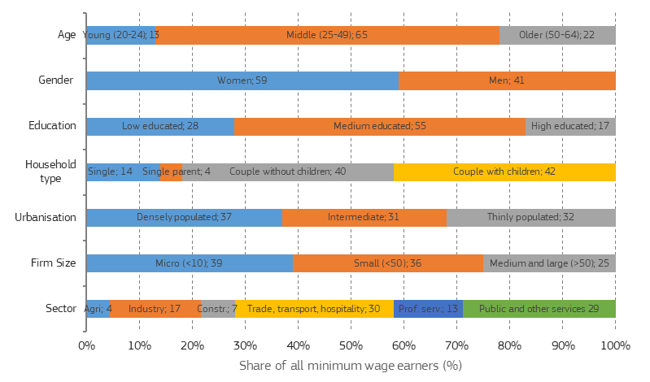

***Note:*** Calculated as the weighted average of percentages in Member States. For Member States without a statutory national minimum wage, data on low-wage earners were used.The definitions of the sectoral breakdown are: Agriculture (NACE Rev. 2 sector code: A), Industry (B-E), Construction (F), Trade, Transport and Food services (G-I), Professional and other services (J-N) and Public and other services (O-U).

***Source:*** European Commission calculations based on EU-SILC 2017.

**Figure 2: The probability of being a minimum-wage earner, by age group, gender, and highest level of education, in percent, 2017**

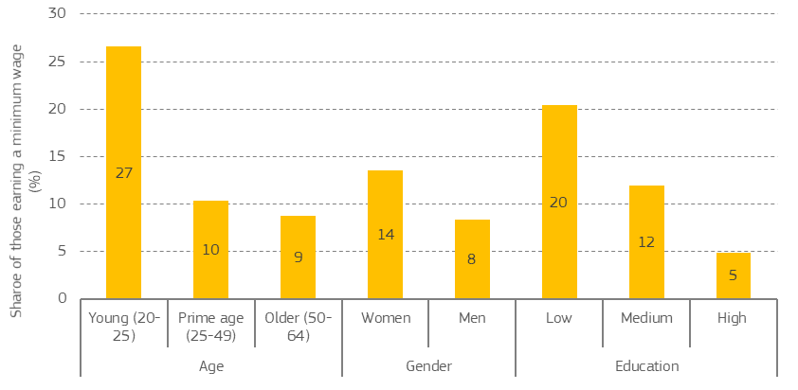

***Note:*** Calculated as the weighted average of percentages in Member States. For Member States without a statutory national minimum wage, data on low-wage earners were used.

***Source:*** European Commission calculations based on EU-SILC 2017.

**Figure 3: The probability of being a minimum-wage earner, by household type and degree of urbanisation of region, in percent, 2017**

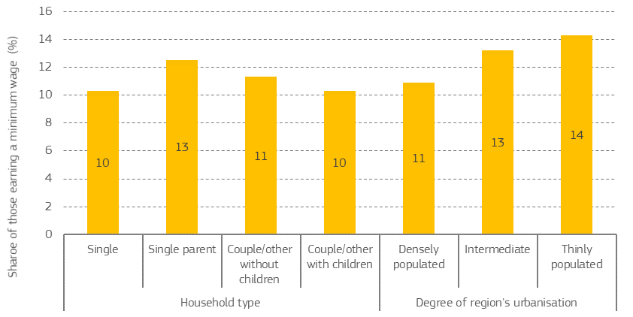

***Note:*** Calculated as the weighted average of percentages in Member States. For Member States without a statutory national minimum wage, data on low-wage earners were used.

***Source:*** European Commission calculations based on EU-SILC 2017.

**Figure 4: The probability of being a minimum-wage earner, by firm size and sector of employment, in percent, 2017**

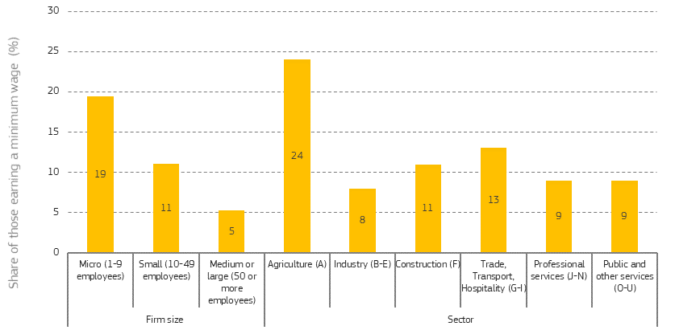

***Note:*** Calculated as the weighted average of percentages in Member States. For Member States without a statutory national minimum wage, data on low-wage earners were used.

***Source:*** European Commission calculations based on EU-SILC 2017.

**Figure 5: Minimum wages, expressed as a percentage of the gross median and average wage of full-time workers, 2018**

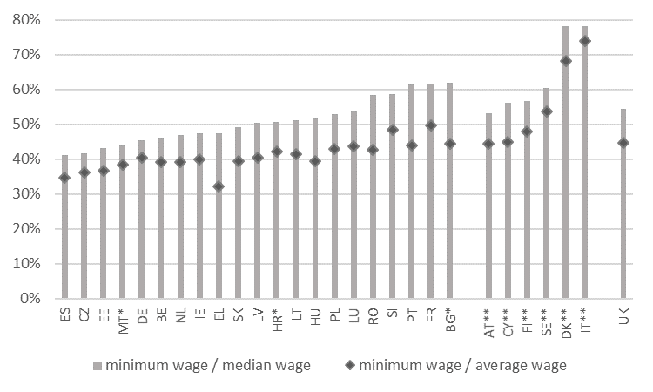

***Notes:*** * For BG, HR and MT, OECD Tax-Benefit data are used for the median and average wage. ** For AT, CY, DK, FI, IT and SE, information on collectively agreed wage floors was taken from Eurofound (2019): Minimum wages in 2019 - Annual review, while information on median and average wages was taken from the OECD Tax-Benefit model.

***Source:*** OECD Stats and Commission calculations based on OECD TaxBen and Eurofound data.

**Figure 6: Collective bargaining coverage in the EU, 2000-2018**

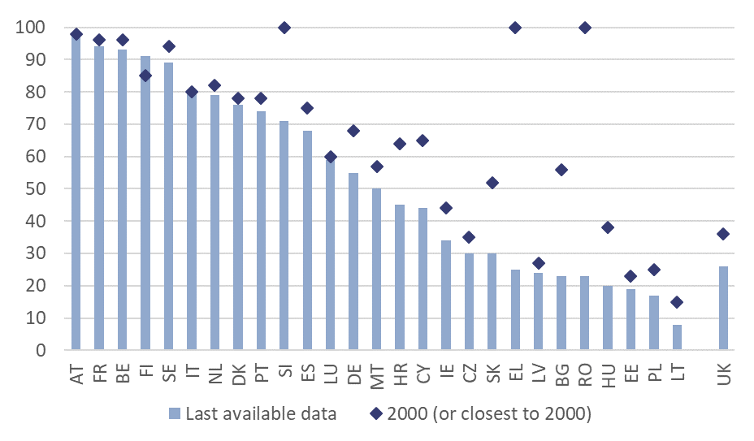

***Notes:*** *Observations closest to 2000 include 1997 (FR), 2001 (LV), 2002 (BG, LT, MT), 2003 (EE). Latest available data are: 2011 (DK); 2013 (SE); 2014 (LV); 2015 (FR, PL, SK); 2016 (CY, FI, BE, BG,CZ, EL, MT, PT, RO, SI); 2017 (DE, ES, HR, HU, IE, LT, LU, NL, UK); 2018 (AT, IT)*

***Source:*** *ICTWSS database, Version 6.1, University of Amsterdam. Variable AdjCov (# 111). Definition: employees covered by valid collective (wage) bargaining agreements as a proportion of all wage and salary earners in employment with the right to bargaining, expressed as percentage, adjusted for the possibility that some sectors or occupations are excluded from the right to bargain.*

**Figure 7: Proportion of low-earning workers who find it difficult to make ends meet, 2015**

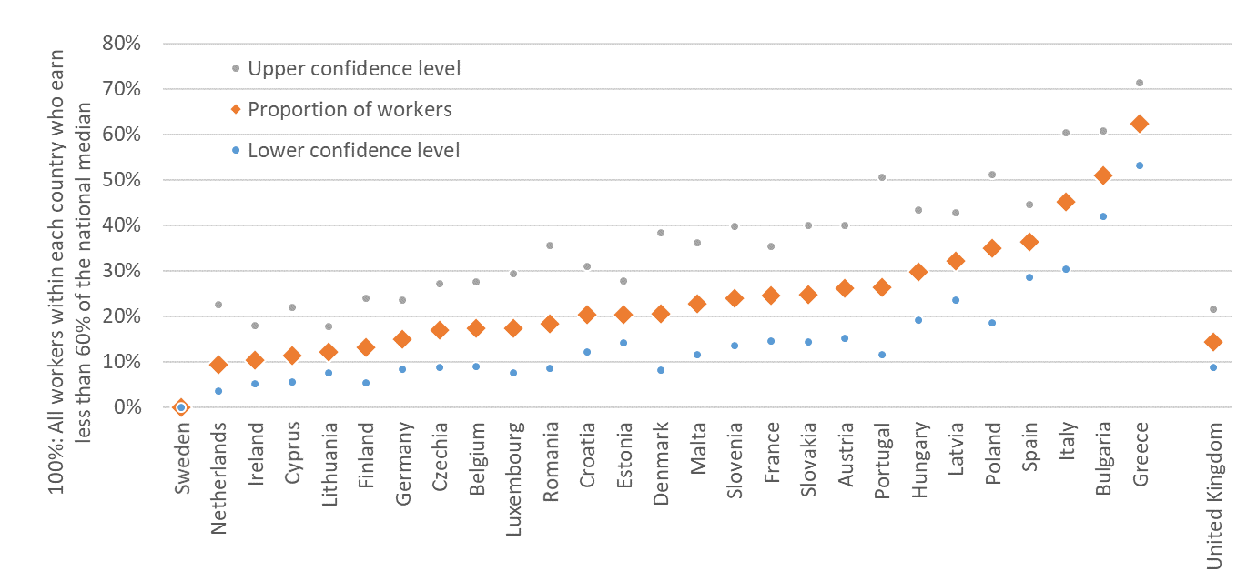

***Note:*** *Responses to the survey question ‘Thinking of your household’s total monthly income, is your household able to make ends meet …?’ The graph shows the sum of those answering ‘with difficulty’ and ‘with great difficulty’. The estimated proportion of workers in each country lies with a likelihood of 95 per cent between the lower and upper confidence level.*

***Source:*** *Eurofound based on European Working Conditions Survey, 2015. See Aumayr-Pintar, C.: “Fears and hopes around future minimum wages”; Link: eurofound.link/ef20039.*

1. In statistical terms, a low-wage is defined as a wage lower than two thirds of the national median wage.
2. “A Union that strives for more. My agenda for Europe.” Political Guidelines for the next European Commission 2019-2024.
3. See case C-268/06, Impact, point 123-124.
4. *[Official document reference to be quoted once available].*
5. Social partners provide input to the Commission ahead of the adoption of the Annual Sustainable Growth Strategy (ASGS) and participate in the ensuing discussions. They also provide input to the Commission’s analysis of economic and social developments in each Member State, which feeds into both the Country Reports and the Country-Specific Recommendations.
6. The data refer to the EU27 as of 2007 (i.e. including the UK but excluding Croatia), the only comparable aggregate between both years. In 2014, the EU28 aggregate was also 17.2%. Low-wage earners are defined as those employees (excluding apprentices) earning two-thirds or less of the national median gross hourly earnings in that particular country.
7. In 2014, the year of the latest comparable data, the share of low-wage earners (i.e. earning a wage below 67% of the median wage) was above 20% in ten Member States: Croatia, Estonia, Germany, Greece, Ireland, Latvia, Lithuania, Poland, Romania, as well as the UK. Significant increases as compared to 2006 were recorded in Czechia, France, Germany, Greece, Spain, and in the euro area as a whole. (Source: Eurostat; see also Section 3.2 of the analytical document).
8. The data refer to the EU27 as of 2007 (i.e. including the UK but excluding Croatia), the only comparable aggregate between both years. In the average of the current 27 Member States (i.e. including Croatia and excluding the UK), in-work poverty increased from 8.5% in 2010 (earliest available data) to 9.3% in 2018. In-work poverty is the share of persons who are at work and have an equivalised disposable income below the at-risk-of-poverty threshold, which is set at 60 % of the national median equivalised disposable income (after social transfers).
9. The patterns differ somewhat across Member States. For a discussion of country-specific profiles, see Sections 2.2 and 2.3 of the analytical document.
10. See Labour market and wage developments in Europe - Annual Review 2019, European Commission.
11. Minimum wage adequacy involves two main dimensions: first, their fairness with respect to the wages of other workers in the same country and, second, their capacity to provide workers with a decent standard of living, relative to the income of other groups or in absolute terms. See accompanying analytical document.
12. The minimum wage was below 50% of the median wage in Belgium, Czechia, Estonia, Germany, Greece, Ireland, Malta, the Netherlands, Slovakia and Spain in 2018, while it was below 45% of the median wage in Czechia, Estonia, Malta and Spain. In the same year, the group of countries with minimum wages below 40% of the average wage was almost identical to those below 50% of the median wage, except that it included Hungary but excluded Germany (OECD data; for more detail on these and the following indicators, see Section 3.1 of the analytical document).
13. These Member States are Czechia, Estonia, Germany, Malta, Latvia and Luxembourg.
14. This criterion compares the take-home pay of single workers earning the minimum wage to the net average wage and sets thresholds at 50% and 60%. The take-home pay of single workers earning the minimum wage is below 50% of the net average wage in Bulgaria, Croatia, Czechia, Estonia, Germany, Greece, Hungary, Latvia, Luxembourg, Malta, Poland, Spain and Romania and below 60% (but not below 50%) in France, Ireland, Lithuania, the Netherlands, Portugal and Slovakia.
15. Eurofound has estimated that the share of low-earning workers whose household is able to make ends meet with difficulty or great difficulty ranges from 0% in Sweden and about 10% in the Netherlands and Ireland to proportions near or above 50% in Greece, Bulgaria and Italy. These estimations are based on the European Working Conditions Survey, 2015. Low-wage earners are defined here as full-time workers earning less than 60% of the national median wage. See Aumayr-Pintar, C.: “Fears and hopes around future minimum wages”, January 2020. See also Section 3.1.1 of the analytical document.
16. Although Cyprus does not have a statutory national minimum wage, it does have statutory occupational minimum wages in some low-paid occupations which are typically not covered by collective agreements.
17. In five Member States (Belgium, France, Luxembourg, Netherlands and Slovenia), the automatic indexation of statutory minimum wages takes into account developments in wages and labour costs, while in ten Member States (Germany, Czechia, Croatia, Ireland, Greece, Latvia, Malta, Netherlands, Poland, Slovakia) the law defines either formulas, variables or targets to update the statutory minimum wage that take into account wages.
18. For more detail, see Section 3.3.1 of the analytical document.
19. These Member States are Czechia, Germany, Ireland, Greece, Spain, Croatia, Hungary, Latvia, Lithuania, Poland, Portugal, Slovakia. For more detail, see Section 3.3.2 of the analytical document.
20. See European Commission (2016): “Labour market and wage developments in Europe: Annual Review 2016”, Directorate-General for Employment, Social Affairs and Inclusion.
21. This is the case in Bulgaria, Czechia, Spain, Croatia, Hungary, Latvia, Malta, Poland, Portugal, Slovenia and Romania. The situation has deteriorated in the case of Poland and Hungary in the context of the measures taken during the Covid-19 pandemic. For more detail, see Section 3.3.4 of the analytical document.
22. These countries are Belgium, Czechia, Germany, Estonia, Spain, France, Ireland, Croatia, Lithuania, Latvia, Netherlands and Poland. For more detail, see Section 3.3.3 of the analytical document.
23. These Member States are Belgium, Greece, Spain, France, Ireland, Hungary, Croatia, Luxembourg, Malta, Netherlands and Portugal.
24. Workers carrying out a paid work in the location they choose (e.g. home) which results in a product or a service specified by and owned by the employer.
25. For more detail, see Section 3.3.5 of the analytical document.
26. For more detail, see Section 3.3.5 of the analytical document.
27. For more detail, see Sections 6 and 7 of the analytical document.
28. Article 18 of Directive 2014/24/EU requires Member States to take measures to ensure that employers acting as contractor for the public administration comply with applicable obligations in the fields of social and labour law established by national or EU social and labour rules, applicable collective agreements and/or international law.
29. Art 153.1 TFEU states that: “*1. With a view to achieving the objectives of Article 151, the Union shall support and complement the activities of the Member States in the following fields: (…) (b) working conditions; (…)*”.
30. Art 153(2) (b) also states that “*Such directives shall avoid imposing administrative, financial and legal constraints in a way which would hold back the creation and development of small and medium-sized undertakings*”.
31. For more detail, see Section 7 of the analytical document.