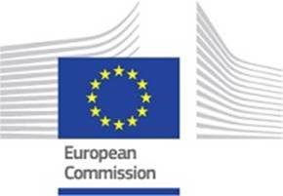

**Crossing all of Europe by train – when is this fully a reality?**

**Welcome to a webinar on train transport in Sweden and in Europe, organised by the European Commission in Sweden**

**Tuesday 6 July 2021, 10.00–10.45**

2021 is the Year of Rail in Europe. The interest in travelling by train is great in Sweden and the EU, not least for climate reasons. Against this background, there is a large demand for fast and efficient train connections within Sweden and to the continent. For the EU, increased train travel is an important part of the green transition. What does the European Commission's project to increase train travel in Europe look like? How big can the climate contribution be? And how can the EU contribute to the financing of Swedish railway projects, including improved connections to the industrially dynamic Northern Sweden?

Many Swedes want to be able to travel by train to the rest of Europe instead of flying. Where does the EU stand on liberalization/increased competition for trains in the EU? When will all- year-round night trains and rational ticket booking to the continent become a reality? And when and how can future Swedish high-speed trains be linked to the continent via the Fehmarn Belt connection?

These are issues that will be discussed at the webinar. The following speakers will participate:

* **Emma Wiesner**, Member of the European Parliament, Center Party
* **Jakop Dalunde**, Member of the European Parliament, Green Party
* **Kristian Schmidt**, Director, responsible for rail transport, European Commission
* **Pär Helgesson**, responsible for high-speed trains, Swedish State Railways
* **Björn Wiman**, Culture Editor, Dagens Nyheter
* **Jessica Wennberg**, CEO, Heart of Lapland

Moderator: **Joakim Berg**, Communications Manager, Norrtåg

The event will be broadcast via [EU-kommissionens](https://fb.me/e/483uuspew) Facebook page and the European Commission’s [YouTube kanal](https://www.youtube.com/watch?v=mUJ8iaTEX-s). The webinar will be held in English.

Welcome!